Exp No:2 **UID-3 Date: 01.02.2025**

**Lab-2: Figma**

**Design a UI where users recall visual elements (e.g., icons or text chunks). Evaluate the effect of chunking on user memory.**

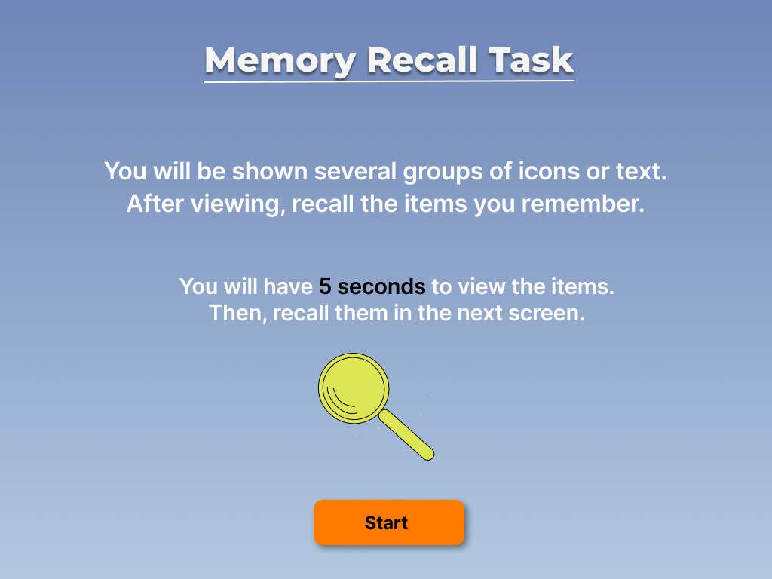**Image 1: Introduction Screen**

1. **Title & Instructions** – The screen introduces the "Memory Recall Task" and explains the challenge: viewing groups of icons or text and recalling them later.
2. **Time Constraint** – Users are informed that they have **5 seconds** to memorize the items before proceeding to the recall phase.
3. **Start Button** – An orange **"Start"** button initiates the task.

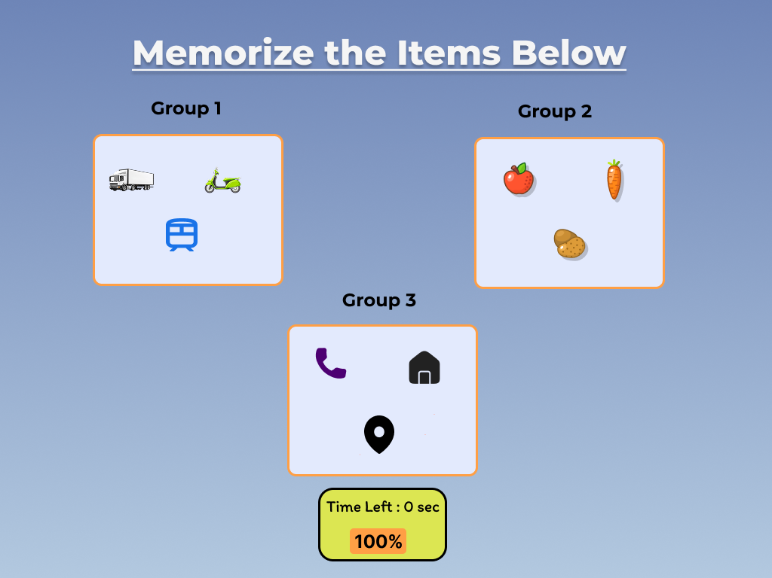**Image 2: Memorization Phase**

1. **Three Groups of Items** – The screen presents **three categorized groups** with different types of objects (transportation, food, and symbols).
2. **Countdown Timer** – A yellow **"Time Left"** box shows the remaining time before moving to the next phase.
3. **Visual Chunking** – The items are grouped logically to aid memorization.

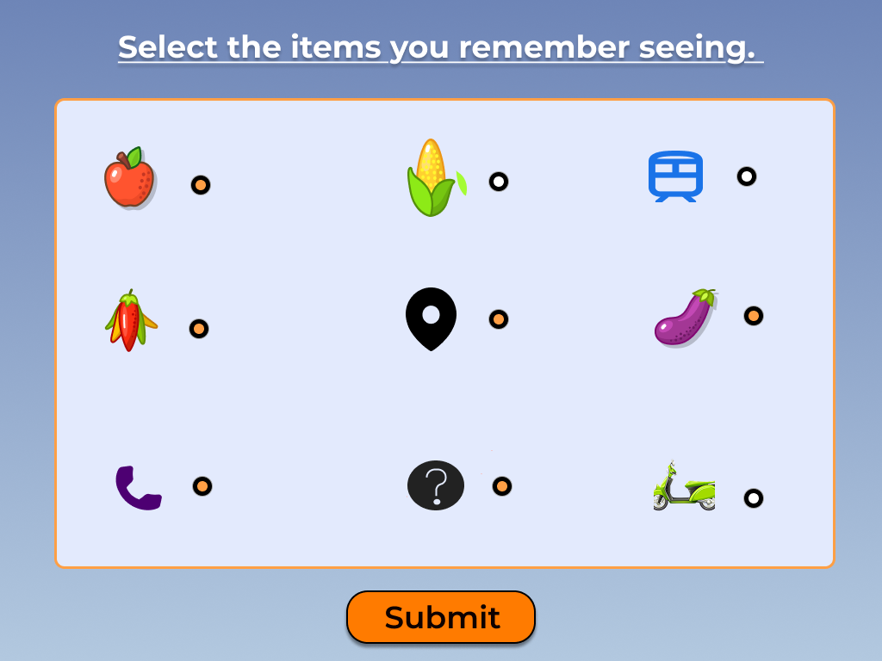**Image 3: Recall & Selection**

1. **List of Possible Items** – The screen provides a **mix of correct and incorrect items**, requiring users to **select what they remember**.
2. **Multiple-Choice Format** – Each item has a **selection circle**, allowing users to mark multiple answers.
3. **Submit Button** – The orange **"Submit"** button finalizes the selection.

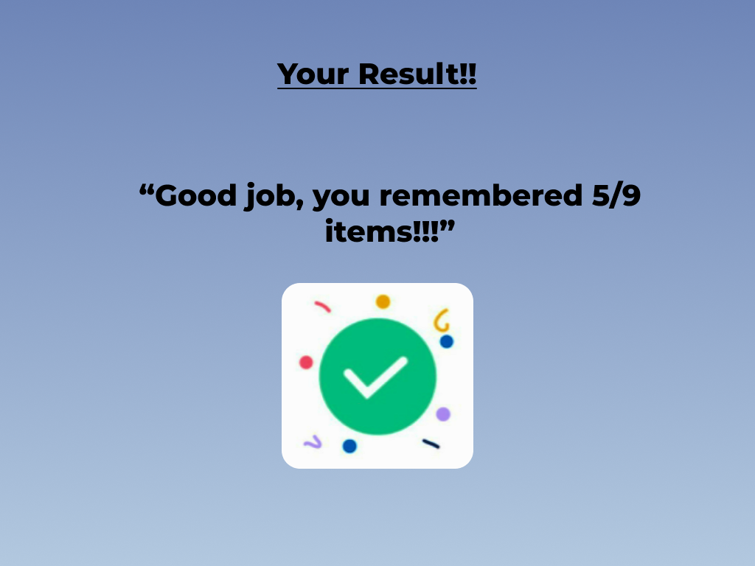**Image 4: Results Screen**

1. **Feedback & Score** – Users receive **instant feedback** on their performance (e.g., "You remembered 5/9 items").
2. **Encouraging Message** – A positive statement reinforces the effort.
3. **Completion Icon** – A checkmark with confetti adds a **rewarding visual**.